Virtual Cybersecurity Infrastructure Lab

Ryan Coon

CYB-525

Dr. Emmett Ward

November 20, 2024

Screenshots:

Windows Server 2019

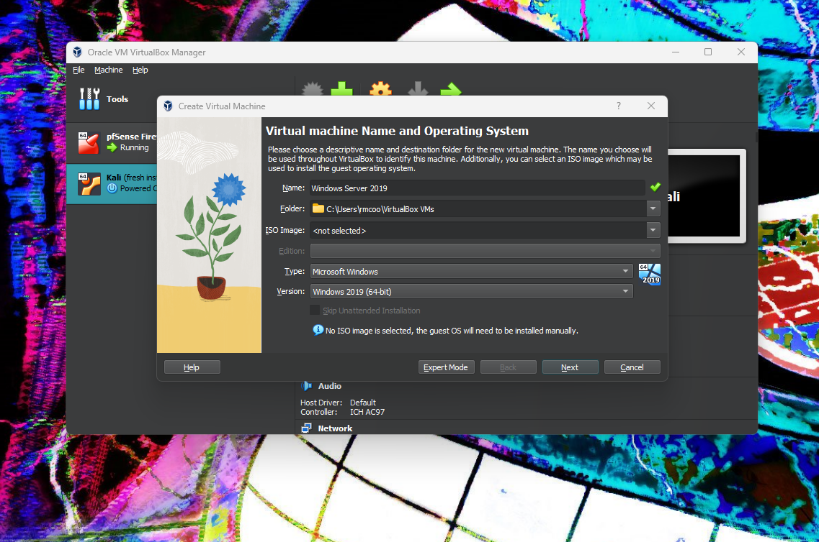

Creating a new virtual machine set for Windows Server 2019.

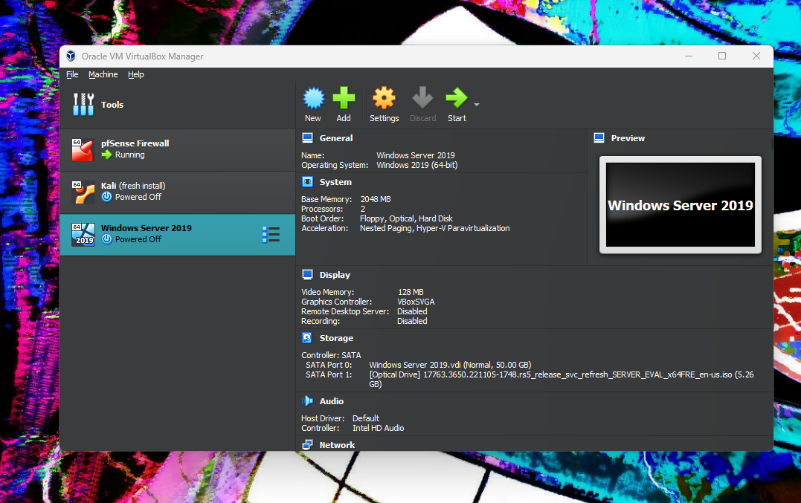

Virtual machine set and ready for initial startup and install.

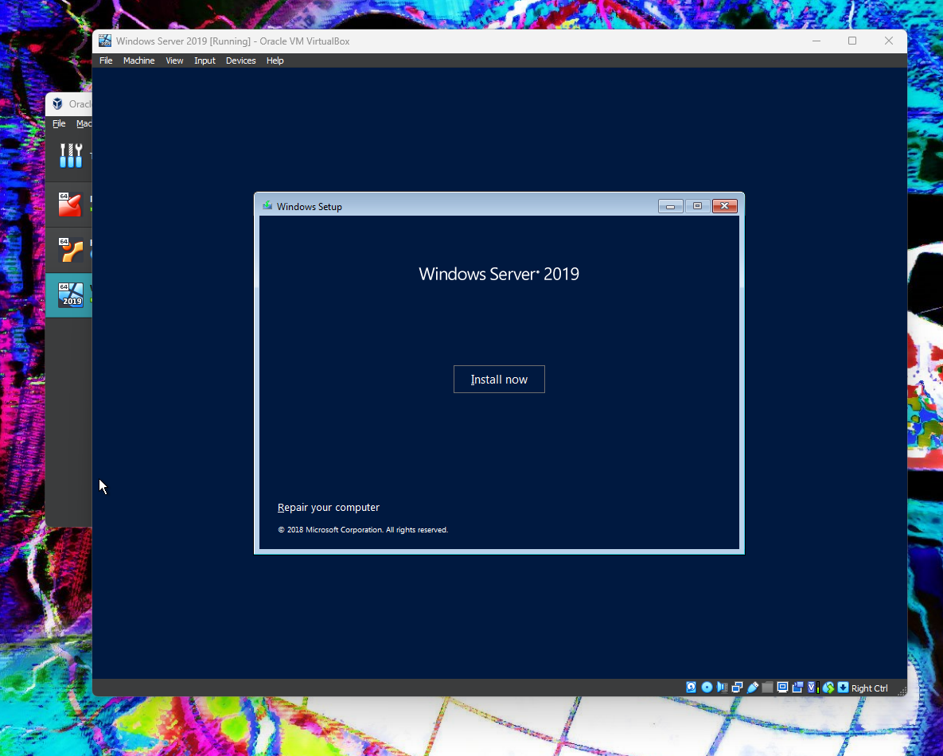

Server started and installing.

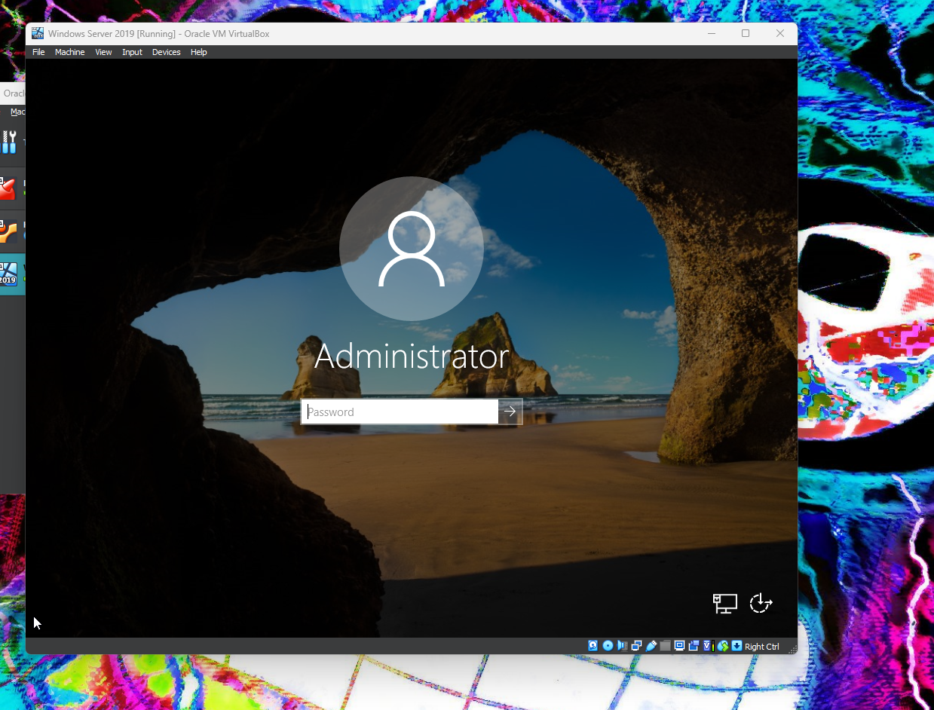

Installation complete and ready for first administrator log in.

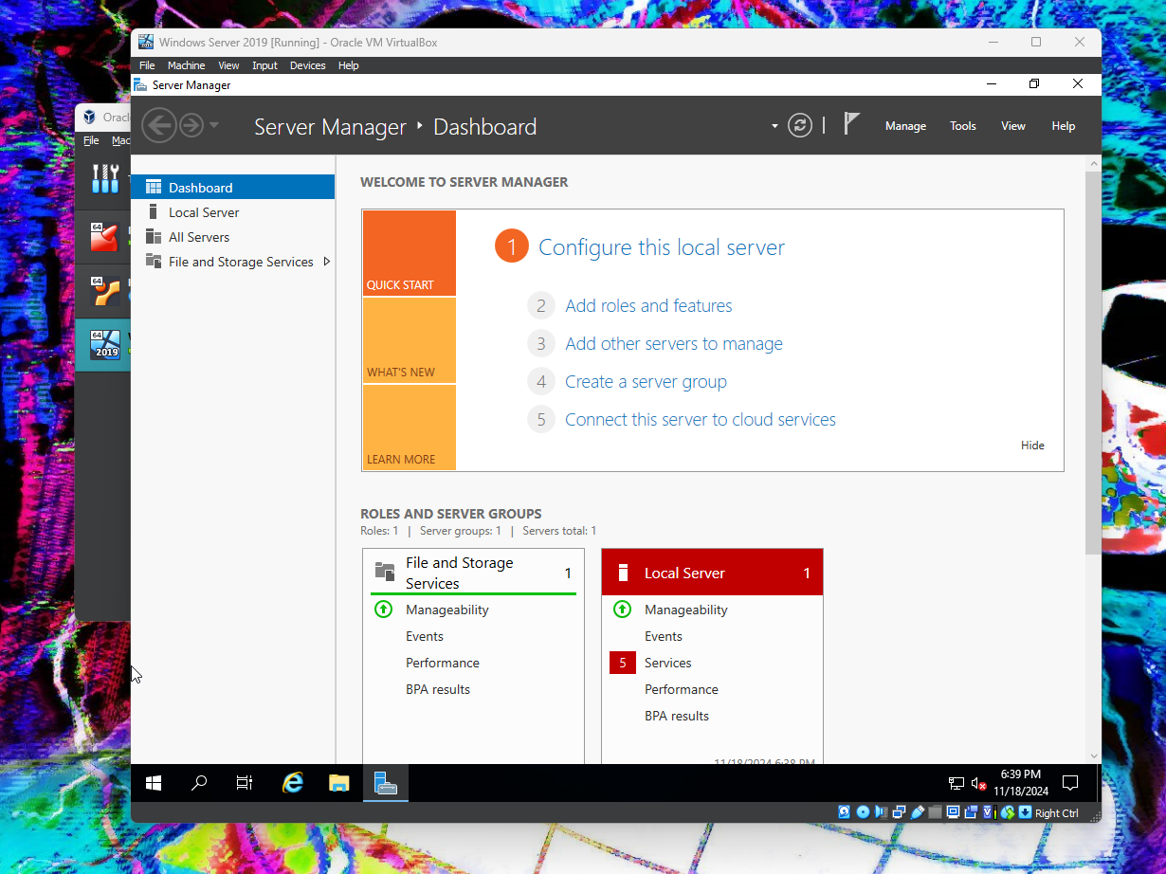

Logged in as administrator and loads up straight to the server manager.

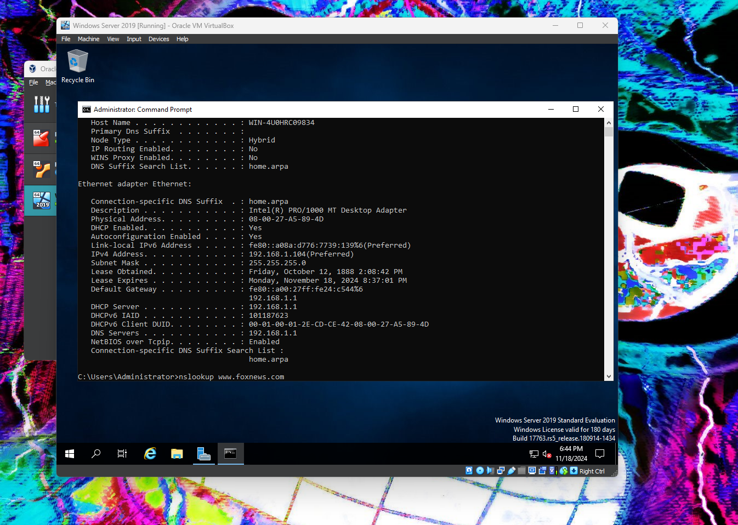

Checked to ensure that the server was getting its ip address from pfSense. It indeed was and its assigned ip address is 192.168.1.104.

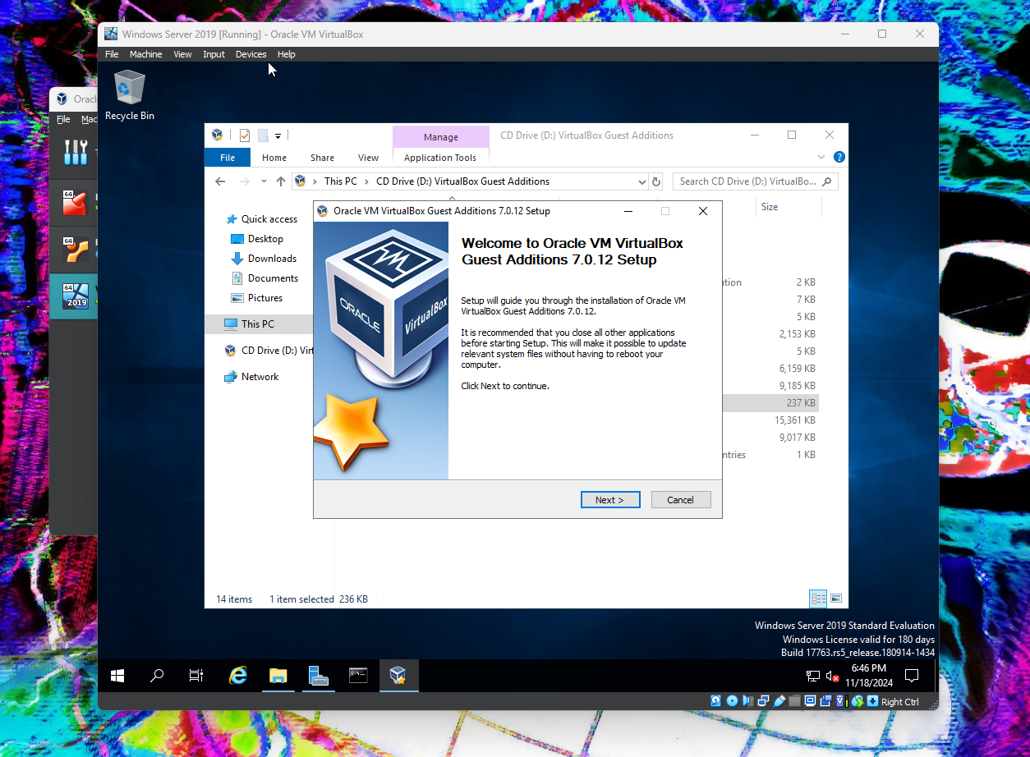

Installing virtual box guest additions.

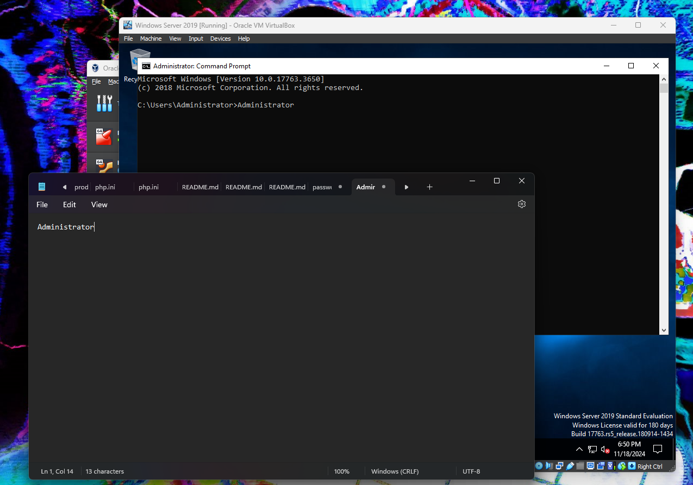

Showing that guest additions now allows us to copy and paste to and from the windows server virtual box.

Screenshots:

Windows 10

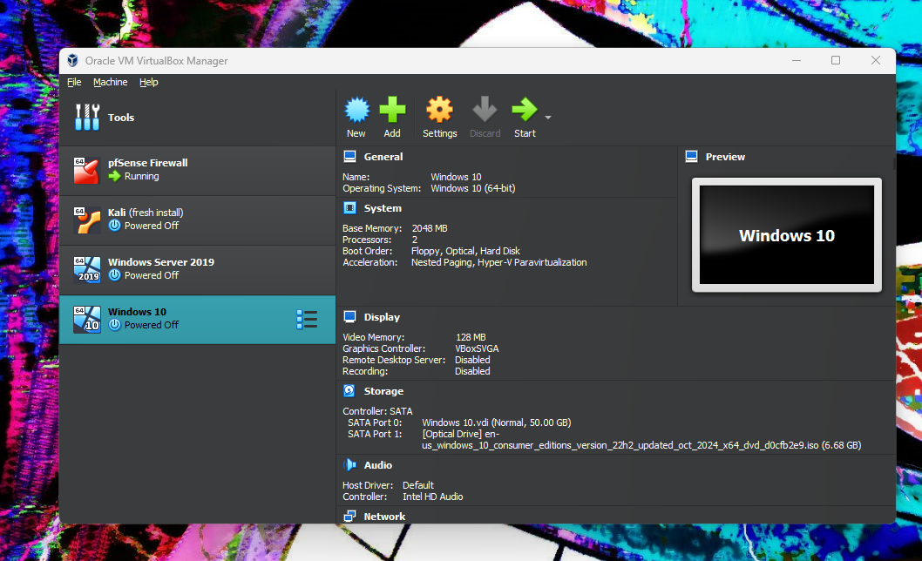

Windows 10 virtual machine set up and ready for its initial start up and install.

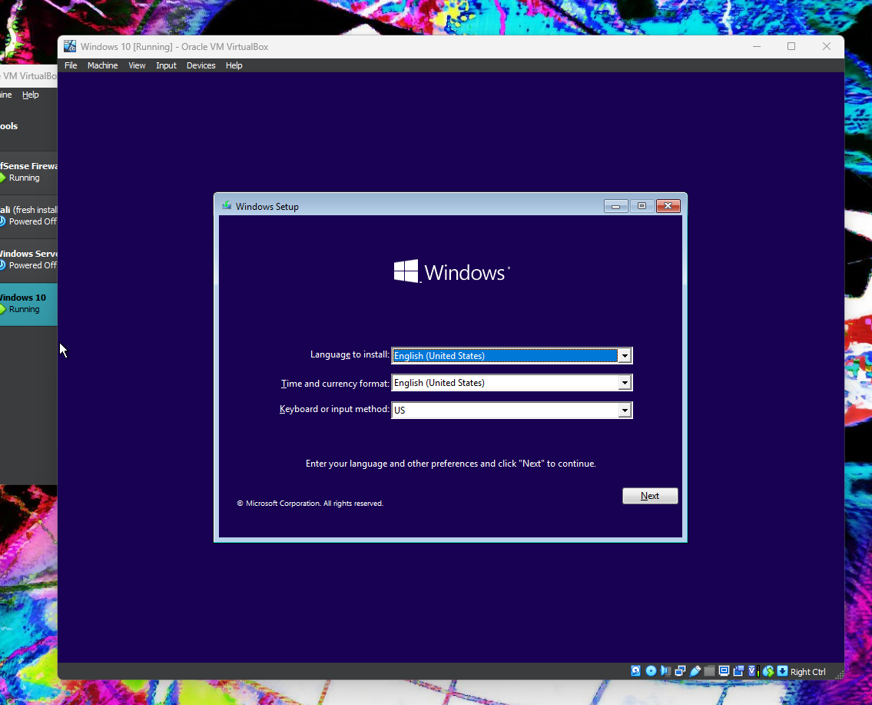

Starting Windows 10 Installation.

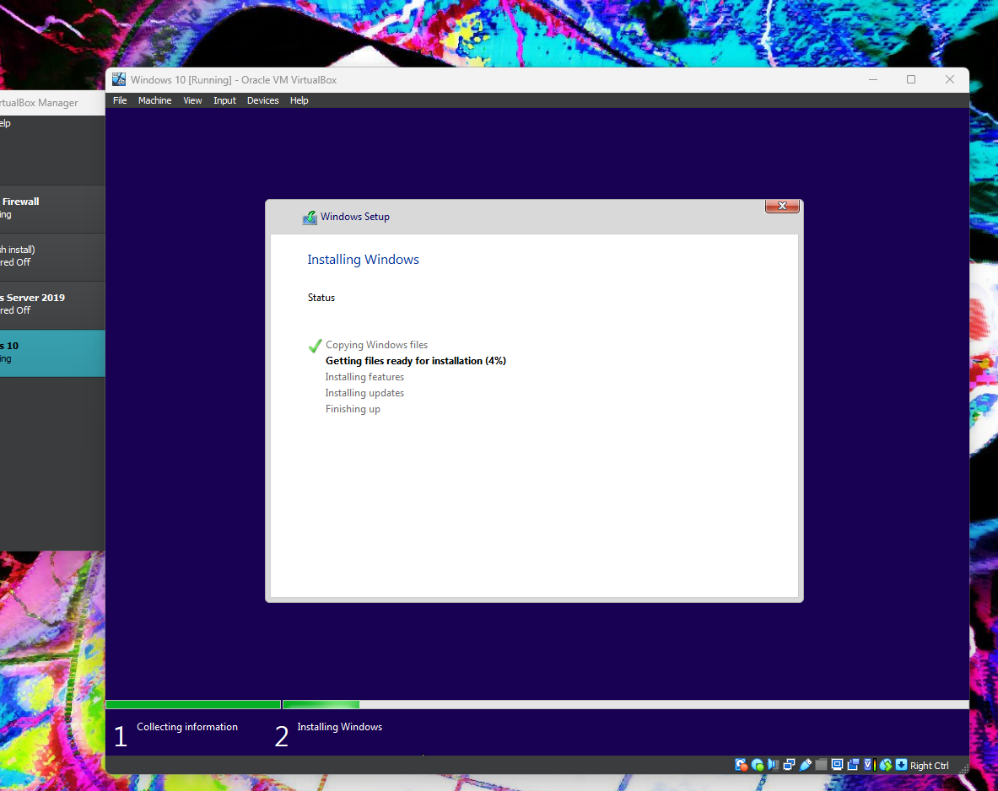

Installation is ongoing.

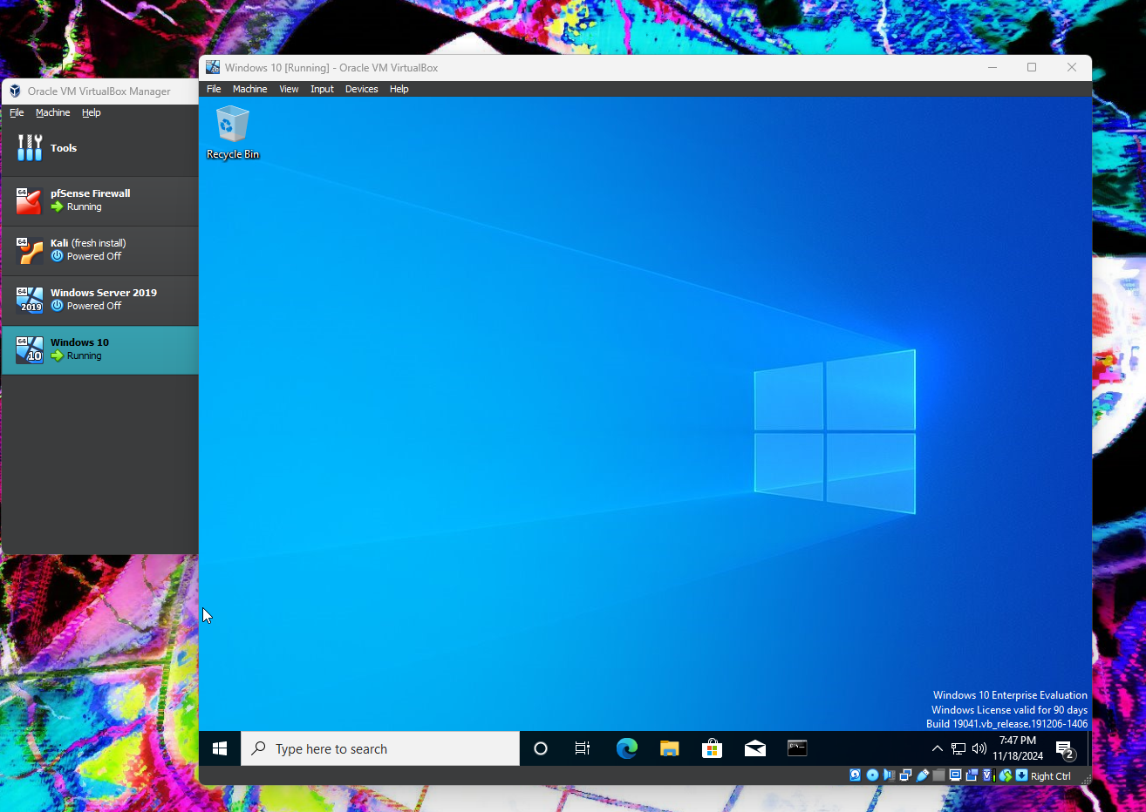

Windows 10 has installed and is running.

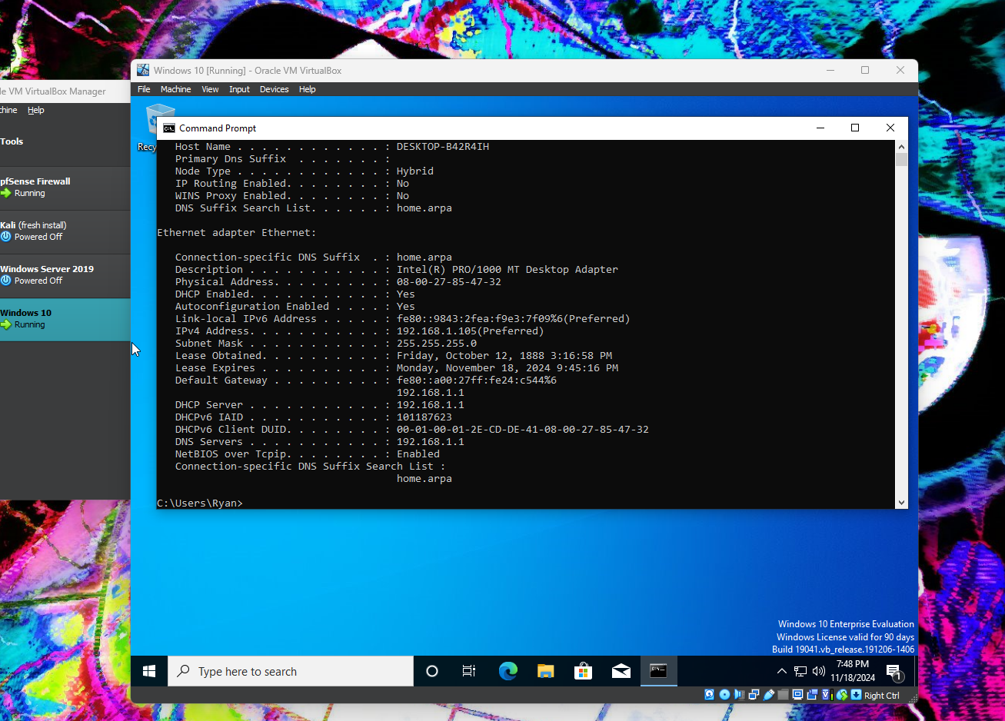

Network is up and running , as we see from the ip address it is receiving from pfSense. The ip address for this device is 192.168.1.105.

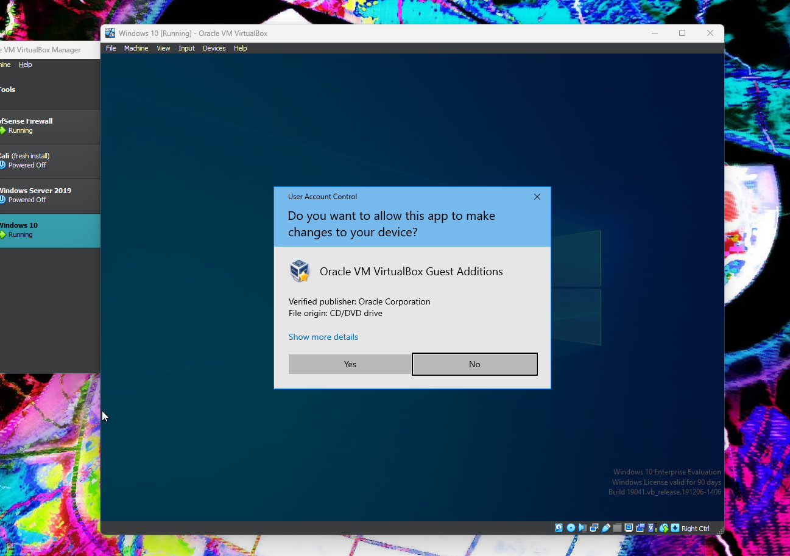

Finally we are installing the Vbox guest additions.

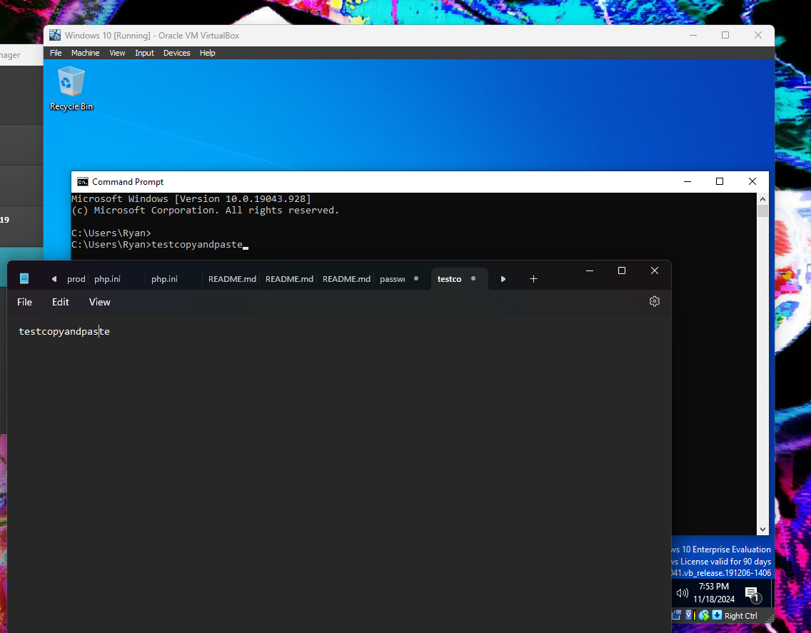

Testing the ability to copy and paste between the virtual box and my pc.

Screenshots:

Ubuntu

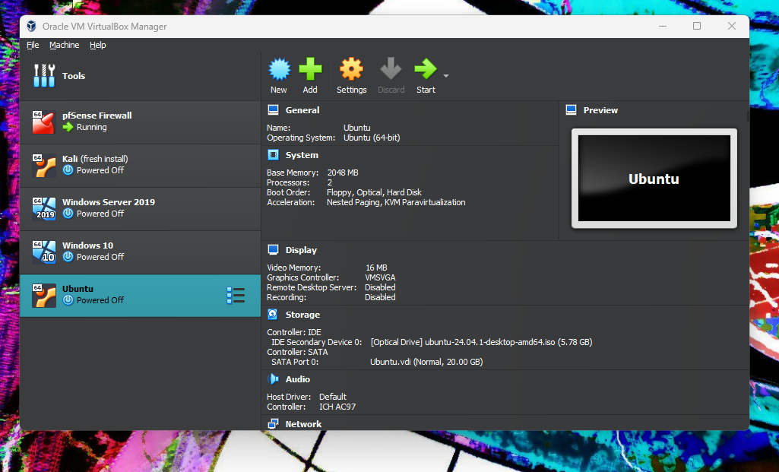

Ubuntu VM setup and ready for initial startup and installation.

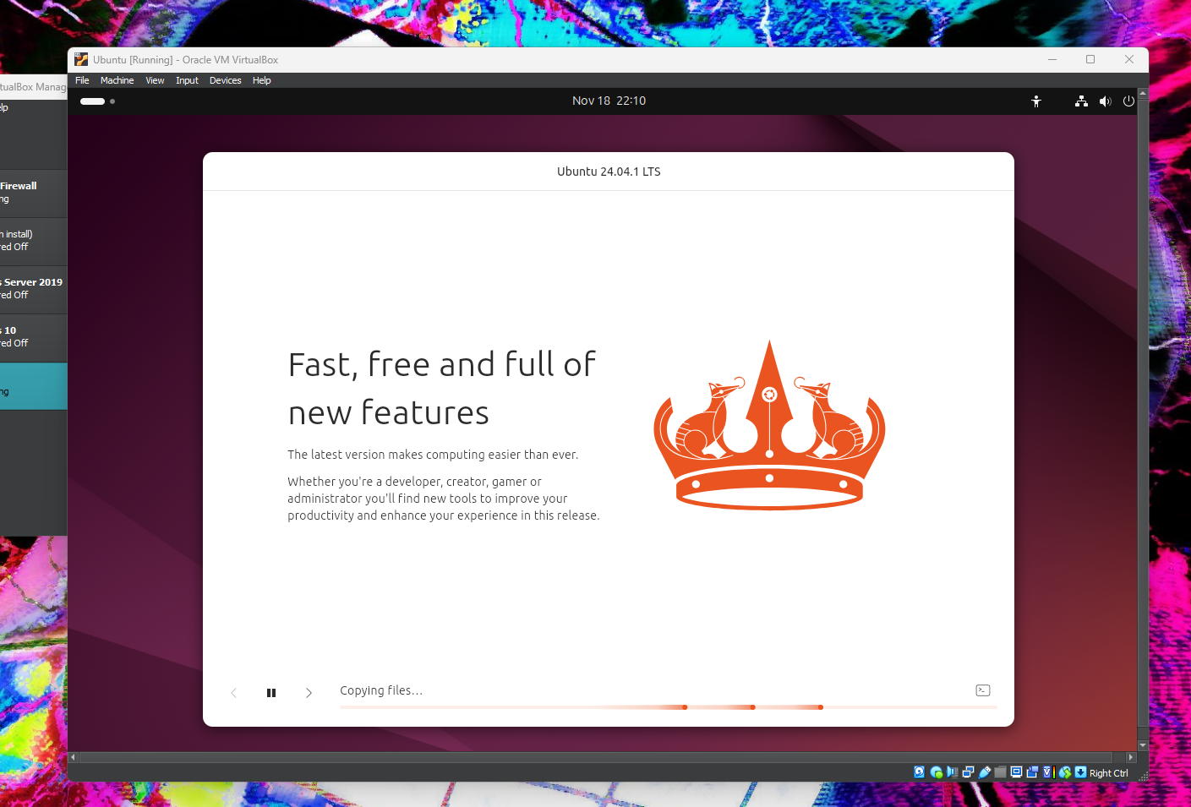

Installation of Ubuntu in progress.

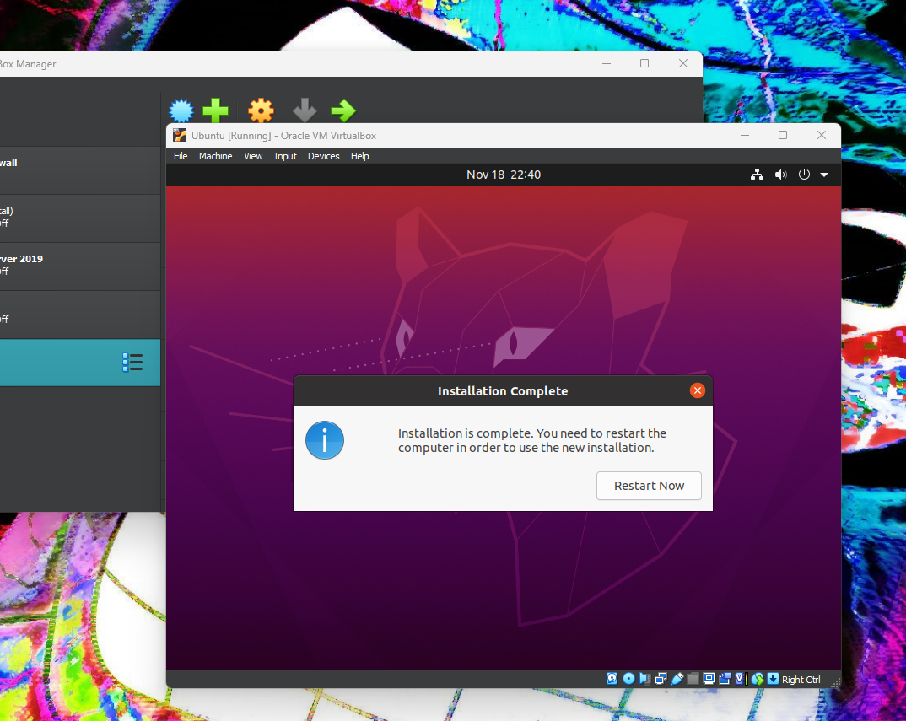

Installation of Ubuntu is complete.

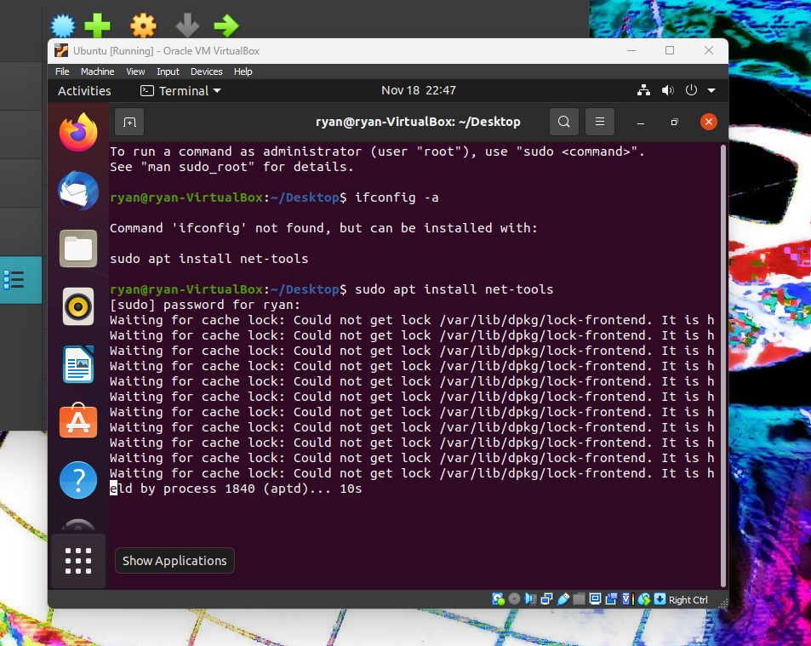

Attempting to check ip address, ifconfig is not installed. Began installation of net-tools.

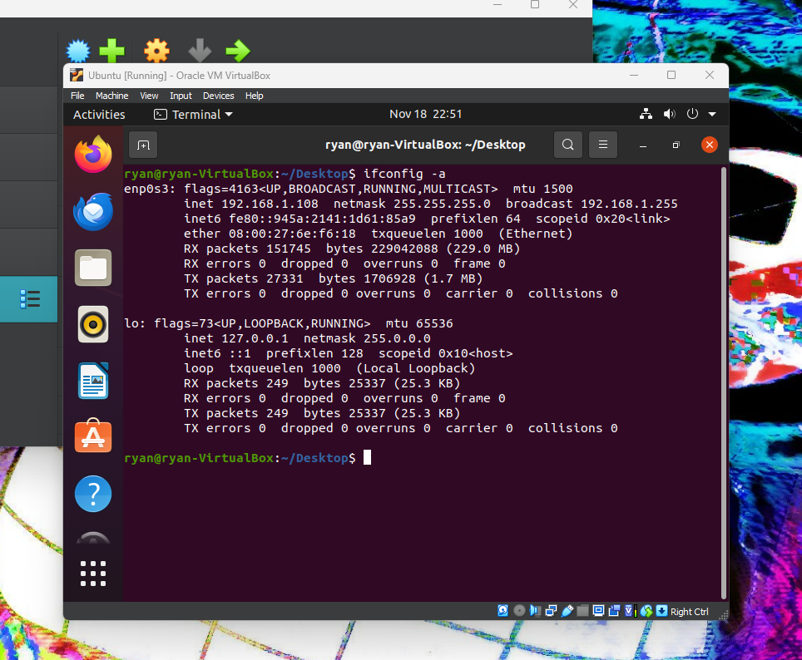

Once installed, ran ifconfig again to see what the ip address on this vm was. PfSense has assigned this vm the following ip address: 192.168.1.108.

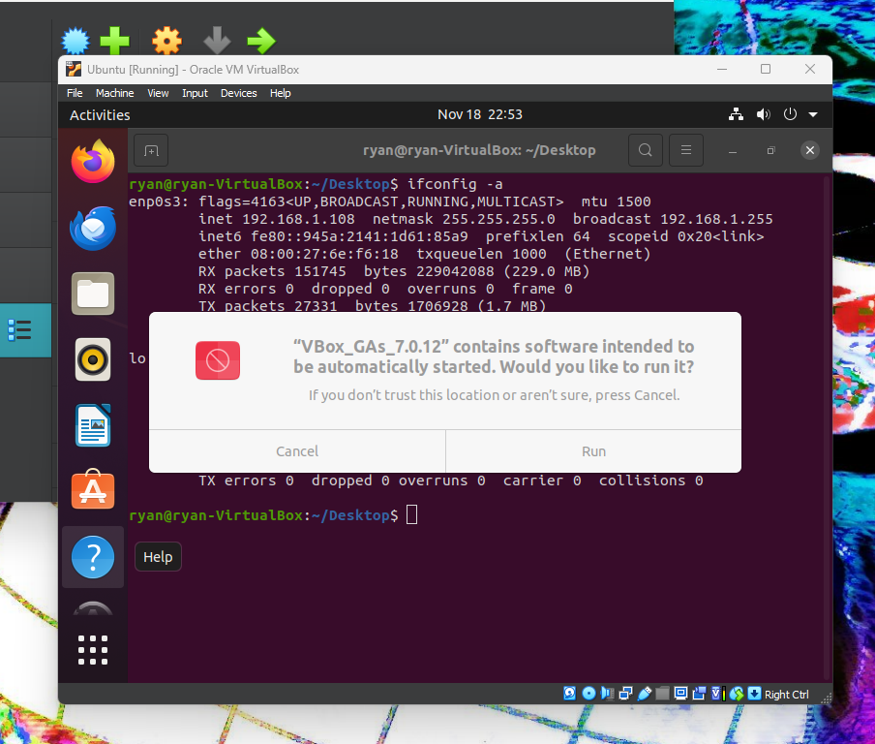

Lastly we will install the virtualbox guest additions.

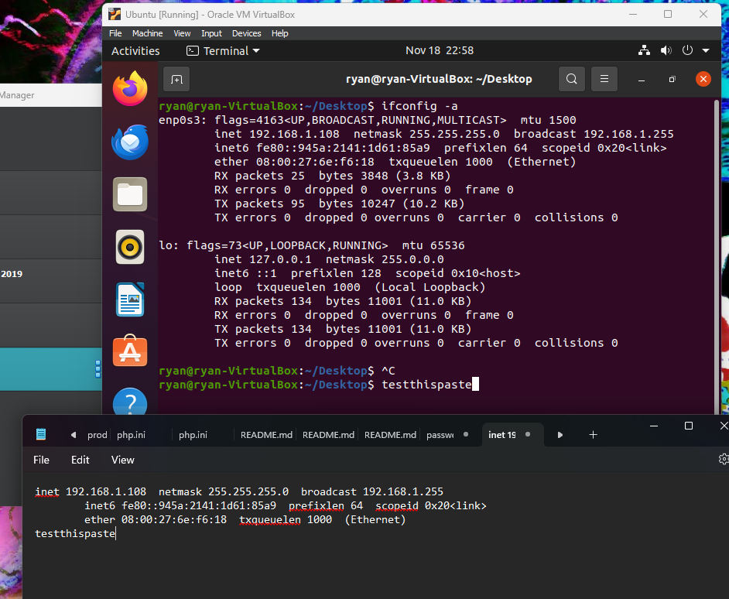

Here you can see that we ensured that the copy and paste is working between the vm and my pc.

A list of the Virtual box servers and their respective ip addresses:

pfSense ip - 192.168.1.1

Kali - schwifty - ip - 192.168.1.13

Windows Server 2019 – Ryan - ip - 192.168.1.104

Windows 2010 – Ryan - ip - 192.168.1.105

Ubuntu – Station 2 - ip - 192.168.1.108

Screenshots pinging each vm:

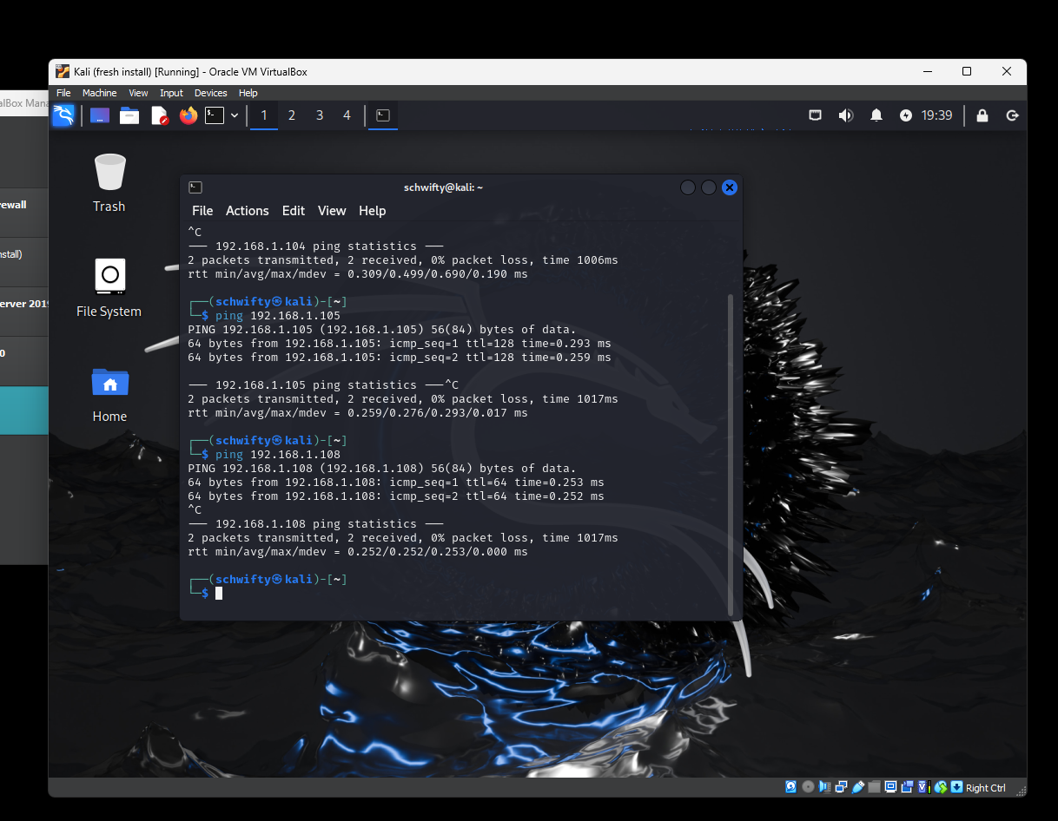

Pinged each other VM from Kali Linux successfully. Had to go onto the Windows Server 2019 and Windows 10 VM and turn off the firewall in order to get the pings to work.

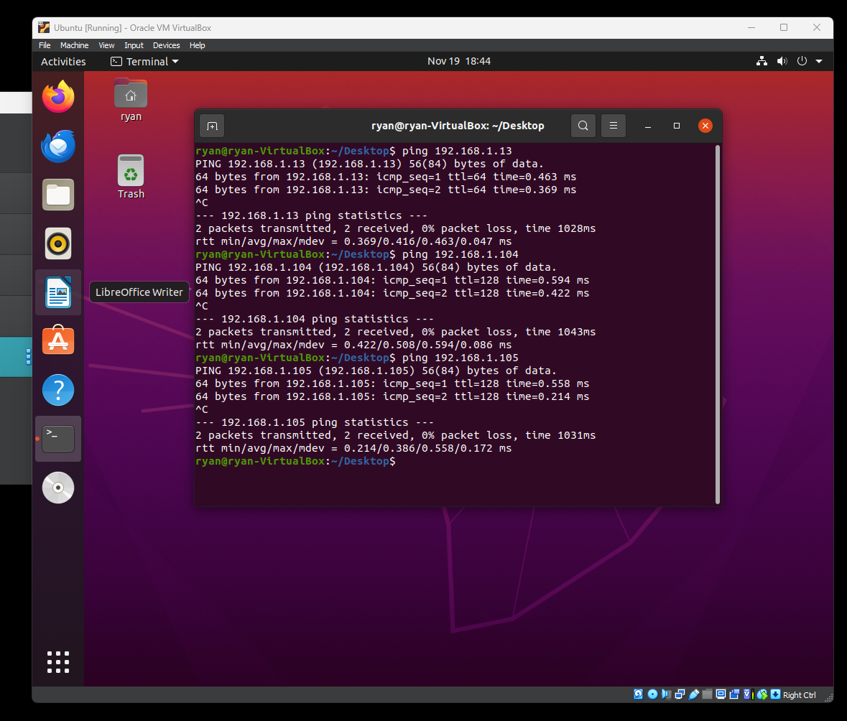

Successfully pinged the other VM’s from the Ubuntu VM

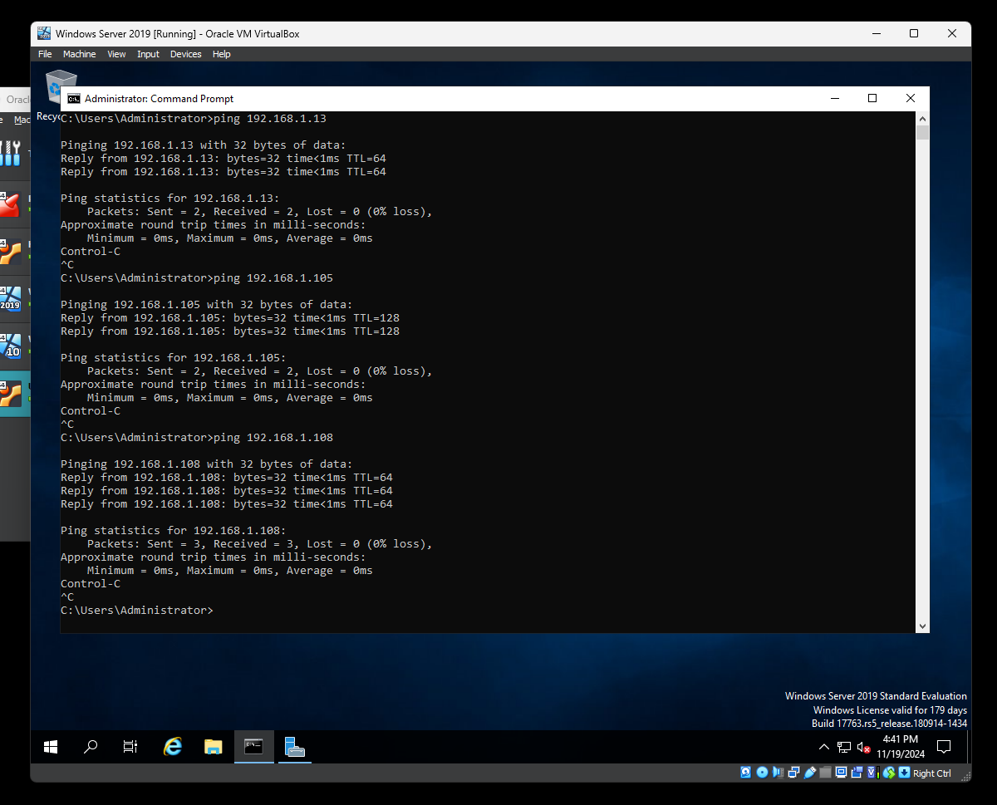

Successfully pinged the other VM’s from the Windows Server 2019 VM.

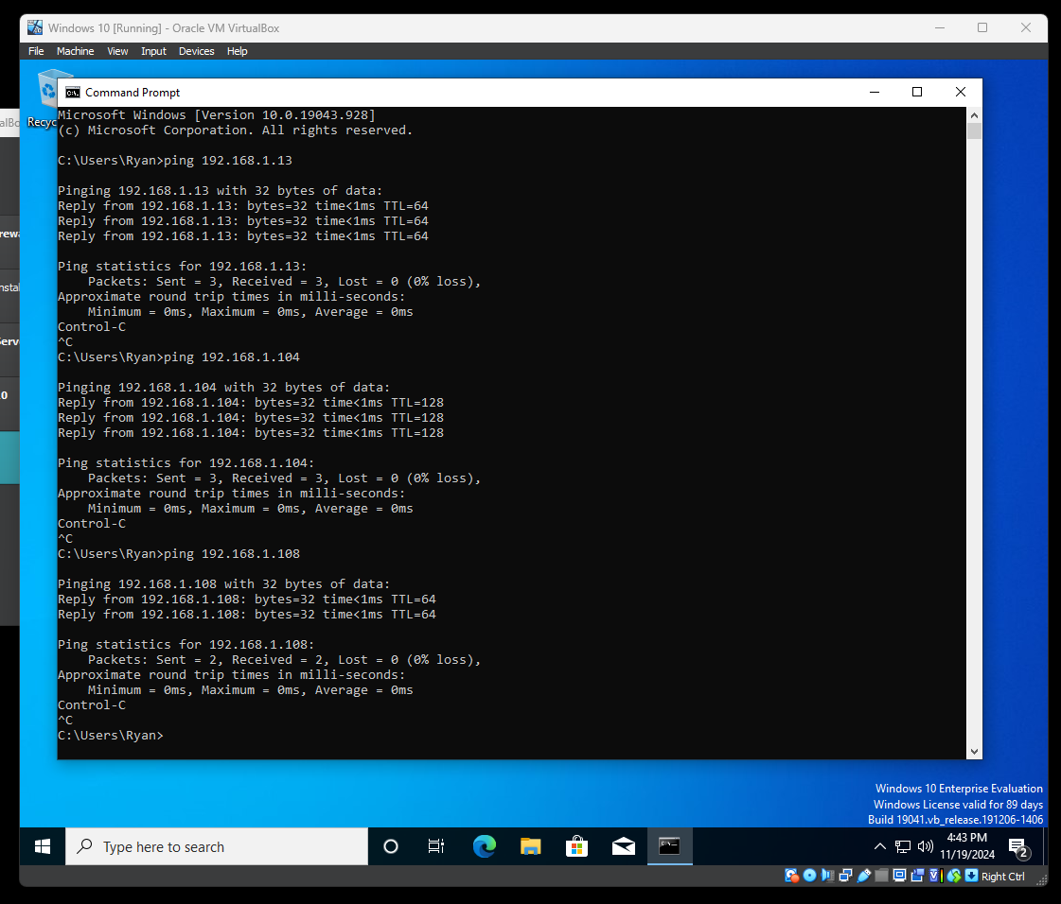

Successfully pinged the other VM’s from the Windows 10 Vm.